V

ALLAMANO SPECIAL SCHOOL
P.O BOX 1102 NYERI; TELEPHONE: +254 721 569 862
specialschoolallamano@gmail.com: www.friendsofallamano.org

TO WHOM IT MAY CONCERN

RE: REQUEST FOR SUPPORT
Allamano Special School is a boarding institution that provides specialized education, therapy and care for children with various mental and physical disabilities helping them reach their full potential and lead fulfilling lives. The school currently has an enrolment of 48 boys and 52 girls totaling to 100 students.
Due to funding gaps, the school is grappling with aging infrastructure that has resulted in total breakdown of some of the core facilities that support the students well-being.
We are therefore writing to request your assistance in provision of the following facilities: -
S.NO | ITEM | AMOUNT
 | General Repair Works | 159,720.00
 | Plumbing Works | 158,100.00
 | Tank Platform / Water Tank | 120,800.00
 | Septic Tank / Soak Pit | 147,800.00
 | Toilet Block | 556,240.00
 | Labour for the above | 342,798.00
 | Commercial Laundry Machine
 | Washer | 679,995.00
 | Drier | 459,995.00
TOTAL AMOUNT |  | 2,625,448.00

We thank you in advance and look forward to your continued support.
Yours Faithfully
FOR: ALLAMANO SPECIAL SCHOOL

BOARD OF MANAGEMENT (BOM)

An Institution for Learners with Intellectual and Developmental Disabilities

To help illustrate the challenges we are facing, we have attached several photographs showing the current state of some of our facilities.
A DECOMMISSIONED TOILET BLOCK

LAUNDRY BEING DONE MANUALLY DUE TO BROKEN DOWN WASHING MACHINE
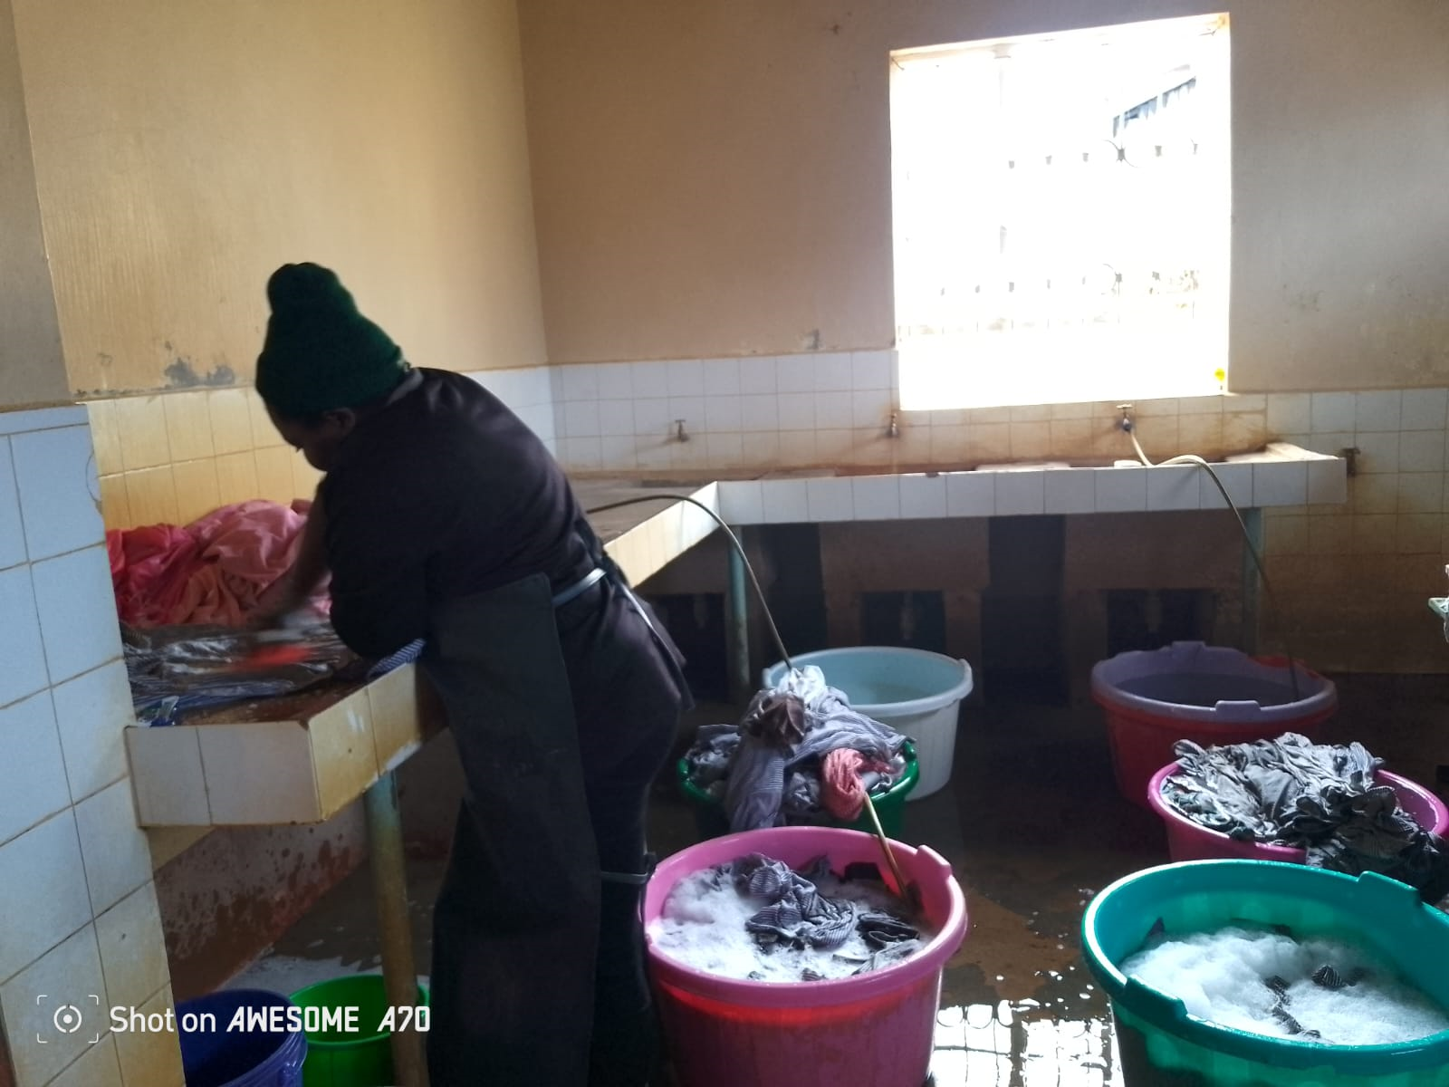
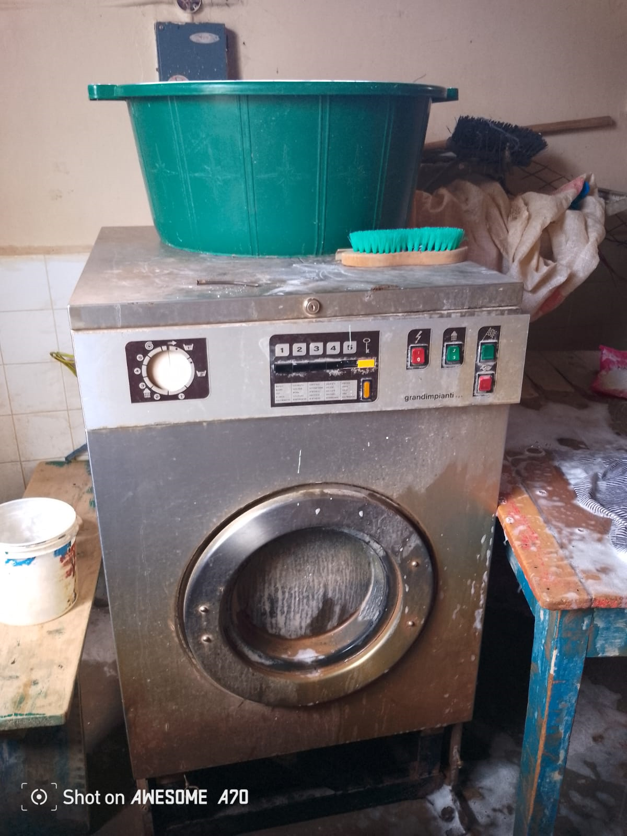

DILAPIDATED KITCHEN AREA WITH BROKEN DOWN JIKOS
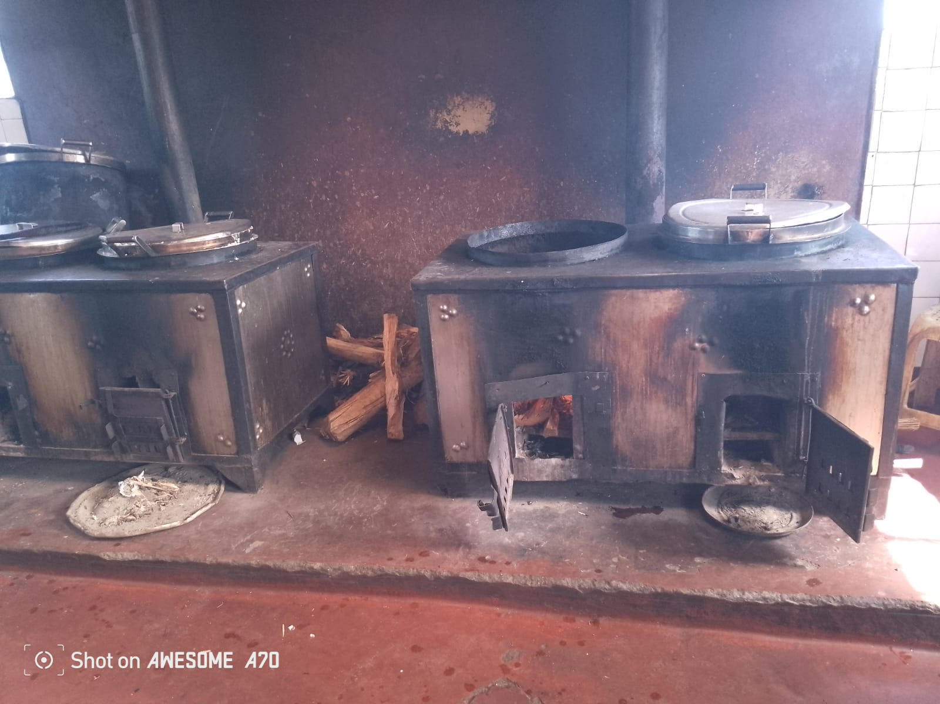
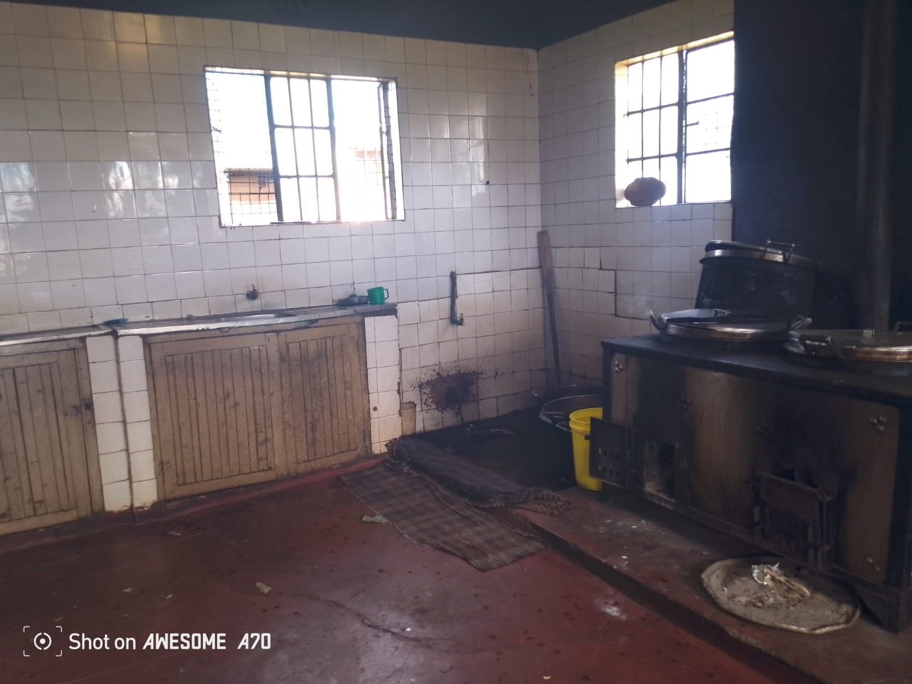

PHOTO GALLERY
